SILEX is a mini-framework that uses the MVC architecture. It has been developped by the same guys that created Symfony.

NOTE: when you create your composer.json, it will send the info when you run composer install in the console and look for the apps specified in your JSON file

Alright! First create index.php in the web directory and implement the application.

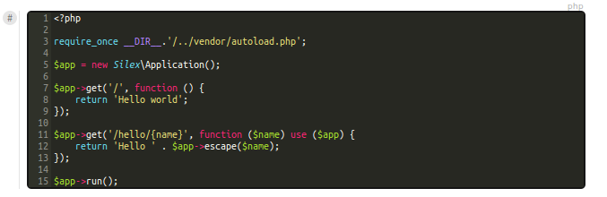
- Autoload
- Create the application
- Get the function
- run the app

NOTE: There are TWO fucking underscores on each side of DIR, not one. Two.

Defining the behavious of the app when you ask for the root URL like this, with a function inside a function, is called a closure.

Let's define a new route in our app!

Escape() allows to avoid external injections through the navbar.

Now, the app says hello {name} when you type in the url $dir/web/index.php/hello/name. But we want it to work even if we type in $dir/web/hello/name. To do this, we need to define a virtual host.
Then, after restarting apache2, you need to add that information to the hosts file so that DNS resolution points to local server
In /etc/hosts ,

The only way to get rid of the filename in the adress bar is to setup a virtual host in the conf of apache2; first create a portfolio.Conf file in /etc/apache2/sites-available and follow the instructions here:
https://openclassrooms.com/courses/premiers-pas-avec-le-framework-php-silex

Once the virtual host is established, you still need to update the DNS conf

DEBUGGING ON APACHE
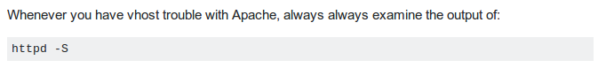
On uBuntu, it is apache2 -S

!!!!!!!
URLGeneratorProvider doesn't have to be declared (in fact, it doesn't work when you do, in spite of what all the doc says).
!!!!!!!

Providers are like services


